
Koneru Lakshmaiah Education Foundation
(Deemed to be University estd. u/s. 3 of the UGC Act, 1956)
Off-Campus: Bachupally-Gandimaisamma Road, Bowrampet, Hyderabad, Telangana - 500 043. Phone No: 7815926816, www.klh.edu.in

STUDENT CASE STUDY EXECUTION REPORT
Department | FED
Subject | DSA-2
Academic Year | 1-111 Semester | 2025-26
Faculty Name | Ms. P.Surekha
Student Name | M.Sreeya
Roll Number | 2500032243
Branch | CSE
Course Outcome | 12SC1305E
Case Study Topic: Cyber Threat Risk Monitoring System
Work Done Summary:
In this case study, we implemented a BST and AVL Tree–based cyber threat indexing framework for efficient malicious IP management and real-time threat monitoring.
The BST structure was used for threat record insertion, while AVL balancing operations maintained optimized and balanced storage for faster threat retrieval. I inserted multiple suspicious IP records into the framework and observed balancing operations like LL, RR, LR, and RL rotations.
I also implemented duplicate attack frequency tracking, threat severity classification, automatic threat blocking, and risk score analysis to improve cybersecurity monitoring efficiency.
Implementation Details:

1. Logged suspicious IP activities dynamically using BST insertion logic.

2. Maintained balanced threat storage using AVL balancing operations.
3. Performed LL, RR, LR, and RL rotations whenever balance factor exceeded the allowed limit.
4. Implemented search operation for fast malicious IP detection and retrieval.

5. Added duplicate attack frequency tracking for repeated cyber attacks.

6. Implemented automatic blocking mechanism for critical threat records.
7. Calculated dynamic risk scores based on attack severity and attack frequency.

8. Concluded AVL Tree is better for scalable cyber threat indexing because operations are performed in O(log n) time.

Result: Screenshots / Output
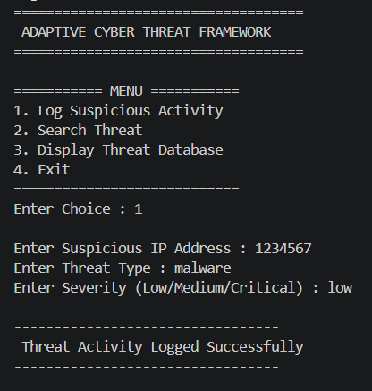 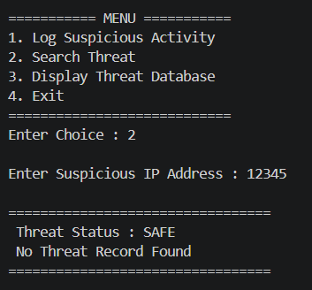 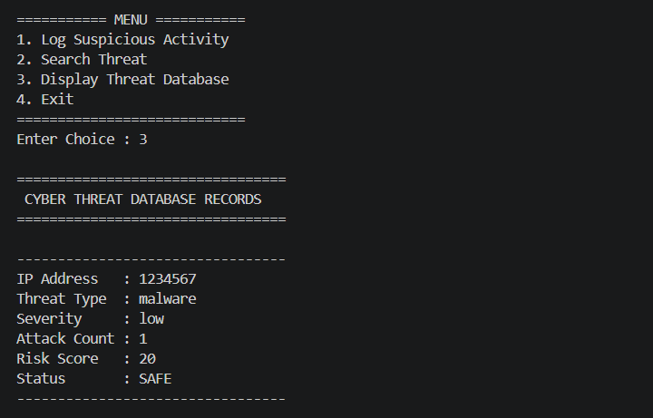
The cyber threat indexing framework successfully stored and managed suspicious IP records using BST and AVL Tree operations.
The system efficiently detected malicious IP addresses, tracked repeated attack attempts, calculated dynamic risk scores, and automatically blocked critical threats.
AVL balancing operations improved search and retrieval efficiency, making the framework suitable for scalable real-time cyber threat monitoring applications.
Time Complexity:
• AVL Tree Insertion : O(log n)
• Threat Search Operation : O(log n)
• Threat Retrieval Traversal : O(n)

GitHub Link: https://github.com/medipallysreeya-commits/Adaptive-Cyber-Threat-Indexing-Framework.git
Student Signature | Faculty Signature

